**Q-1. What is software? What is software engineering?**

**Ans. Software:**

* **Software is a collection of programs and instructions that enable a computer to perform specific tasks.**

**Software Engineering:**

* Software engineering is a field of computer science and engineering that focuses on the design, development, testing, and maintenance of software systems.
* It involves applying engineering principles to create software that is reliable, efficient, and meets user needs.
* Here are some key aspects of Software Engineering**:**

1. Requirements Analysis
2. System Design
3. Implementation
4. Testing
5. Maintenance

**Q-2. Explain types of software.**

**Ans. Types of Software:**

1. **Application Software:**

* Application software is a type of computer program designed to carry out a particular task or function for the user, or sometimes to assist another software application.
* An application can be self-contained, or it can be a group of programs that run the application for the user.
* **Example:** Ms-office etc…

1. **System Software:**

* These software programs are built to manage and operate a computer's application programs and hardware.
* It manages the functions of the computer's hardware and creates a framework or environment in which all other types of software can operate.
* The OS (Operating System) is a key type of system software that controls and organize all the other programs on a computer.
* **Example:** File manager, Notepad etc…

1. **Driver Software:**

* Often referred to as device drivers, this software is typically classified as a type of system software.
* Device drivers manage the hardware and peripherals attached to a computer, allowing them to carry out their designated functions.
* Each device connected to a computer requires at least one device driver to operate properly.
* **Example:** Audio driver, Video driver etc…

1. **Middleware:**

* Middleware refers to software that acts as an intermediary between application software and system software, or between different types of application software.
* It is also used to send a remote work request from an application in a computer that has one kind of OS, to an application to work with legacy ones.
* **Example:** Database middleware etc…

1. **Programming Software:**

* Computer programmers use programming software to write code.
* Programming software and programming tools enable developers to develop, write, test and debug other software programs.
* Examples of programming software include assemblers, compilers, debuggers and interpreters.
* **Examples:** Turbo C, VS code etc…

**Q-3. What is SDLC? Explain each phase of SDLC**

**Ans. SDLC:**

* SDLC stands for Software Development Life Cycle.
* SDLC is a structured process that is used to design, develop, and test good-quality software.
* SDLC, or software development life cycle, is a methodology that defines the entire procedure of software development step-by-step.

**Phase of SDLC:**

1. **Requirements gathering and analysis:**

* This phase involves gathering information about the software requirements from stakeholders, such as customer, end-users, and business analysts.

1. **Design:**

* In this phase, the software design is created, which includes the overall architecture of the software, data structures, and interfaces.

1. **Implementation or coding:**

* The design is then implemented in code, usually in several iterations, and this phase is also called as Development.

1. **Testing:**

* The software is thoroughly tested to ensure that it meets the requirements and works correctly.

1. **Deployment:**

* After successful testing, the software is deployed to a production environment and made available to end-users.

1. **Maintenance:**

* This phase includes ongoing support, bug fixes, and updates to the software.

**Q-4. What is DFD? Create a DFD diagram on Flipkart**

**Ans. DFD:**

* DFD stands for Data Flow Diagram.
* Data Flow Diagram represents the flow of data within information systems.
* Data Flow Diagrams provide a graphical representation of the data flow of a system that can be understood by both technical and non-technical users.

**DFD diagram on Flipkart:**

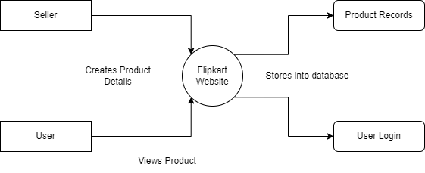

**Q-5. What is Flow chart? Create a flowchart to make addition of two numbers.**

**Ans. Flow chart:**

* A flowchart is a type of diagram that represents a workflow or process. A flowchart can also be defined as a diagrammatic representation of an algorithm, a step-by-step approach to solving a task.

**Flowchart for Adding Two Numbers:**

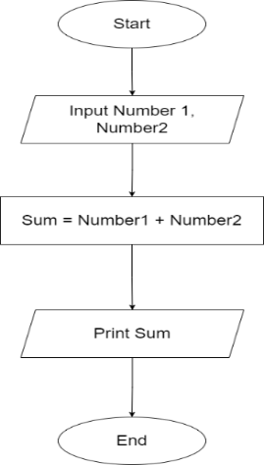

**Q-6. What is Use case Diagram? Create a use-case on bill payment on Paytm.**

**Ans. Use case:**

* A use case diagram is a graphical depiction of a user's possible interactions with a system.
* A use case diagram shows various use cases and different types of users the system has and will often be accompanied by other types of diagrams as well.

**Use-Case Scenario for Paying Bills on Paytm:**

